***MethodsX* methods article template***Version 3 (July 2022)*

**Before you complete this template**, a few important points to note:

* This template is for a methods article. If you want to describe a protocol or changes you’ve made to a protocol; for example, for use in a clinical or drug trial, please complete our [protocol article template](https://www.elsevier.com/__data/promis_misc/MethodsX-Protocol-Article-Template.docx).
* The format of a methods article is very different to a traditional research article. To help you write yours, we have created this template. **We will only consider methods articles submitted using this template**.
* Please consult the *MethodsX* [Guide for Authors](https://www.elsevier.com/journals/methodsx/2215-0161/guide-for-authors); it highlights mandatory requirements and is packed with useful advice. We have also developed a [step-by-step video guide](https://www.journals.elsevier.com/methodsx/about-methodsx/video-how-to-submit-your-methods-article-to-methodsx) to completing this template, designed to maximize your chances of acceptance.

**Still got questions?**

* Email our editorial team at [mexjm@elsevier.com](mailto:mexjm@elsevier.com)

Now you are ready to fill in the template below. As you complete each section, it’s important to read the associated instructions carefully. All sections are mandatory, unless marked OPTIONAL.

**Please delete this line and everything above it before submitting your article. In addition, we ask you to delete the instructions, including those featured in the Article Information and Specifications table.**

- - - - - - - - - - - - - - - - - - - - - - - - - - - - - - - - - - - - - - - - - - - - - - - - - - - - - - - - - - - - - - - - - - - - - - -

**Article information**

**Article title**

Optimization model for multi-product multi-period multi-supplier raw-material selection and composition, and order quantity problem with minimum one-year order quantity contract.

**Authors**

Mohammad Rizka Fadhli *

Saladin Uttunggadewa

Rieske Hadianti

Sri Redjeki Pudjaprasetya

**Affiliations**

Magister of Computational Sciences Program, Institut Teknologi Bandung, Center for Advance Sciences 4th floor, Jalan Ganesha no. 10, Bandung 40132, Indonesia.

Faculty of Mathematics and Natural Sciences, Center for Advance Sciences 4th floor, Jalan Ganesha no. 10, Bandung 40132, Indonesia.

Center for Mathematical Modeling and Simulation, Gedung Labtek III 1st floor, Jalan Ganesha no. 10, Bandung 40132, Indonesia.

Faculty of Mathematics and Natural Sciences, Center for Advance Sciences 4th floor, Jalan Ganesha no. 10, Bandung 40132, Indonesia.

**Corresponding author’s email address and Twitter handle**

20921004@mahasiswa.itb.ac.id

**Keywords**

inventory control, multi-period multi-product multi criteria raw-material selection, mix-integer

linear programming

**Abstract**

This paper concerns the optimization model for a multi-product multi-period raw-material selection and

composition, and order quantity problem faced by a beverage company. There are some criteria in raw

material selection, which we accommodate all the criteria in the objective function. There are a number of

suppliers, and one of the decision criteria is minimum one-year order quantity contract between the company and the suppliers. The actual one-year demand of raw materials may deviate significantly from the minimum one-year order quantities. In this paper, we derive a function that can be regarded as a penalty function in order to maintain the total order quantities in one year fulfil the minimum one-year order quantity contracts. This penalty function is a part of the objective function and can be relaxed once the minimum one-year order quantity contracts are fulfilled.

We performed a number of numerical experiments to check the optimal solutions for various demands

and for various objective functions. These experiments show our MILP gives the desired optimal solutions

and also show the influence of decision criteria on the optimal solution.

**Graphical abstract**

**Specifications table**

|  |  |
| --- | --- |
| **Subject area** | Mathematics and Statistics |
| **More specific subject area** | Operation Research and Optimization |
| **Name of your method** | Multi-Criteria Supplier Selection using Mixed-Integer Linear Programming |
| **Name and reference of original method** | Multi-Criteria Supplier Selection |
| **Resource availability** | Data can be found in: https://github.com/ikanx101/MILP_Methodx |

**Method details**

**1. Introduction**

This paper concerns the optimization model for supplier selection, order allocation, and raw-material composition in a beverage company that produces a large number of drink powders. There are a number of suppliers that can provide the same key raw material of the drink powders, but the color or some physical characteristics are slightly different so we may assume those raw materials are different. The drink powders produced by this company, which in the remainder of this paper are called items, can be classified into two classes of items.

* The first class consists of items that can be produced by using exactly a single type of raw material.
* The second class consists of more flexible items, where each item in this class can be produced by using one raw material or by using a composition of a number of raw materials. For each item in this class, we then have a set of possible raw materials. The sets of possible materials may vary from one to the other.

In order to avoid supply disruption, the company decides to use multiple sources for these raw materials. The company has established selection criteria for each raw material, which are based on the estimated one-year total demand of raw materials and a subjective assessment of whether the raw material cannot be substituted, price, service, and the minimum order required for each purchase. After determining the score for each raw material, the company decided to make contracts or agreements with six suppliers. Each contract stated the unit price price and the minimum order quantity within a year. Based on these contracts, production planning and inventory control of raw materials are carried out.

The estimated total one-year demand for items is obtained from the forecasting process performed yearly. This forecasting process yields the monthly total demand for items, which is time varying. But at the production level, the company refines the monthly total demand on a monthly basis as a response to some disruptions such as sudden additional requests due to flash sales practices in e-commerce, and others.

Once the demand for items for a month is issued, the company must perform the decision for purchasing the raw materials from some suppliers. This purchase decision from a supplier includes purchase for four serial deliveries one week apart. The first delivery must be no later than 17 days before the following month’s start. The period of 17 days here is the total time required for the company’s internal inspection and preparation of raw materials.

This decision process is a complex one since there are a large number of items that have to be produced which mostly belong to the second class, and the monthly demand may vary. Additionally, the company imposes a production regulation for the second class of items as a result of the multiple-sources policy, which states that each item in the second class must be produced using a composition of at least two types of the corresponding possible raw materials. The decision process must be performed carefully in order to obtain results in the form of:

* which raw materials are purchased along with the delivery size for every four corresponding weeks,
* the composition of raw materials for every item in the second class which has to be produced,

while minimizing the total inventory cost.

The company developed a decision support system for this monthly decision process, which is developed based on an optimization model. This paper concerns the derivation of the optimization model, which can be categorized as a multi-product multi-period multi-supplier raw material selection and composition, and order quantity problem. The multi-product multi-period multi-supplier raw material selection problem has been addressed in a number of articles such as Sambatt, Woarawichai, and Naenna (Sambatt, Woarawichai, and Naenna 2018), but they do not address the minimum one-year order quantity contracts so that their optimization problem is simpler than our optimization problem. In general, our optimization problem is much more complex compared to the one criterion supplier selection studied in an enormous articles such as Reck & Long (Reck and Long 1988), Monckza & Trecha (Monckza and Trecha 1988), & Porter, and Harding papers. Later, supplier selection research has developed into a problem with multiple criteria, such as criteria for quality of goods, on time delivery, after-sales service, as well as environmental and socio-political criteria for suppliers (see Smytka & Clemens (Smytka and Clemens 1993), Gray (Gray, Helper, and Osborn 2020)). What is interesting is that in general these criteria contradict each other, for example, goods offered at low prices (positive values for the price criteria) may have negative values for on time delivery criteria. The complexity of this issue is compounded by the fact that some criteria are quantitative (price, timeliness of delivery, specification/quality of goods, etc.), but other criteria are qualitative (after-sales service, environmental and socio-political criteria of suppliers).

The paper by Weber Current & Benton (Co Ao Weber, Current, and Benton 1991) is a paper at the beginning of this research on multi-criteria supplier selection, which presents research results with four criteria, namely Price, Quality, Delivery and Service (PDQS). This paper together with Hurkens, van der Valk, Wynstra (Hurkens, Valk, and F. Wynstra 1993) introduces the supplier selection problem under the concept of Total Cost Ownership (TCO), a financial analysis tool to examine the direct and indirect costs of a product’s production. These direct and indirect costs then become the criteria in the supplier selection process. These papers on TCO include Ferrin & Plank (Ferrin and Plank 2002), Degraeve & Roodhooft (Degraeve and Roodhooft 2000). Our optimization problem is categorized as a multi-criteria one, where one of the criteria is a new one, i.e the minimum one-year order quantity.

After the rise of conceptual research on supplier selection with multi-criteria, then we quite easily find a proposal to use the Analytic Hierarchy Process (AHP), a decision-making method when it comes to ranking of many criteria (see Dyer (Dyer 1990)), as a method of solving supplier problems. selection. AHP provides a framework for addressing various criteria involving intuitive, rational, qualitative and quantitative aspects. Other papers that discuss the AHP approach to supplier selection solutions include Bard, Belton (Belton 1986), Bhutta & Huq (Bhutta and Huq 2002), Nydick & Hill (Nydick and Hill 1992).

Another method proposed as a solution to the supplier selection problem is an optimization method or mathematical programming as proposed by Degraeve & Roodhooft (Degraeve and Roodhooft 2000), Khalifa & Mohammed Al-Shabi (Khalifa and Al-Shabi 2018), and Nispeling (Nispeling 2015). A special optimization method, namely multi-objective goal programming, was proposed by Weber & Ellram (C. A. Weber and Ellram 1993). Multi-objective programming is very suitable to be used to resolve conflicts between existing criteria and the existence of just-in-time scenarios. Meanwhile, Masella & Rangone (Masella and Rangone 2000) offer a dynamic programming method as a method of completing this supplier selection, where input variables are set as controls and environmental variables and status variables are set as the internal workings of the organization, and output variables are seen as company performance. Another optimization method used as a solution method is Data Envelopment Analysis (DEA), as proposed in the paper of Pitchipoo, et al. (Pitchipoo et al. 2013) and Shahrzad, et al. (Shahrzad, Mohammad, and Reza 2021).

Apart from these methods, we get the combined use of the two methods above (hybrid method), such as the one proposed by Li, Wong, & Kwong (Li, Wong, and Kwong 2013) which combines the AHP method and multi-objective programming. Another approach is the metaheuristic method proposed by Alejo-Reyes, et al. (Alejo-Reyes et al. 2020). We accommodate all criteria in one objective function, so that our optimization model can be categorized as a mix-integer linear programming.

**2. Production Planning and Inventory Control for Raw Materials**

As mentioned above, the company deals with six raw material suppliers. The decision process for supplier selection and order allocation is carried out every month based on the results of demand forecasting at the beginning of the year and production performance in the previous month. From this demand forecasting process, the company then makes the purchase and sales agreements with all six suppliers concerning the one-year minimum purchase, unit price, and minimum one-month delivery. The serial process in one calendar year can be seen in figure 1. At the beginning of a month, the company forecasts the demand for items in the following month.

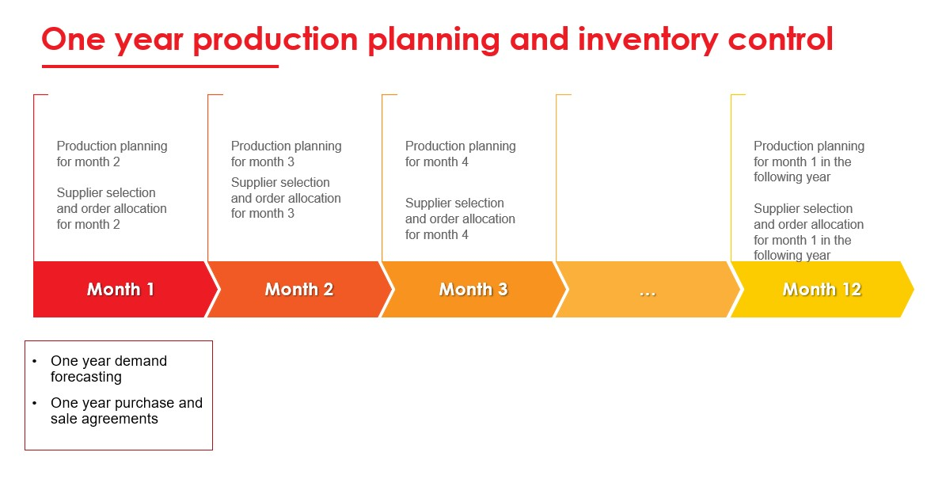

Figure 1. One-year production planning and inventory control

From the estimated monthly demand for items obtained from the yearly forecasting process, we directly can find out the estimated monthly total demand for raw materials in one year. In practice, this one-month estimated demand must be reviewed due to several things, such as production in the previous month experiencing disruptions, sudden additional requests due to flash sales practices in e-commerce, and others. Reviewing the one-month demand and determining the production schedule we call production planning for one month.

As soon as the production planning is performed, the company performs the decision process for purchasing the raw materials from some suppliers. In the following, we assume that one month can be divided into four weeks (the fourth week may be longer than seven days). This purchase decision covers purchases for four serial deliveries one week apart. The first delivery must be no later than 17 days before the following month’s start since the internal inspection and the preparation for the raw materials delivered takes 17 days. Figure 2 in the following illustrates a one-month planning horizon and raw material selection, and four consecutive delivery points follow it.

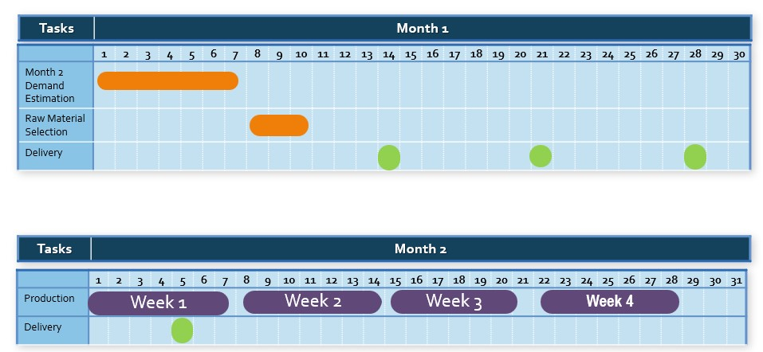

*Figure 2. Decision proccess planning horizon*

The decision process considers some parameters for decision making such as:

* raw materials purchase prices,
* existing stock of raw materials in the warehouse,
* the minimum one-month delivery of raw materials(if ordered),
* the minimum one-year purchase of each raw material,
* raw-material flexibility of each item, which is known by the number of raw materials that can be used to produce the item. The larger this number for an item, the more flexible the item,
* and others.

The purchase must also comply with the company’s internal policies in the following.

**Policy 1.** purchase raw materials from at least two suppliers in order to maintain supply security,

**Policy 2.** if an item must be produced by using more than one raw material, the proportions of raw materials used are the same.

In the following section, we will accommodate all these policies into some constraints of an optimization model that can be regarded as the main engine of the Decision Support System developed by the company in order to achieve an optimal decision in inventory control.

**3. Mathematical Model of the Problem**

In this section, we formulate a mathematical model of the decision problem. As described before, we need to make a decision for raw material selection, delivery quantities, and raw material compositions on the four consecutive weeks covered. In the following, we derive a mixed integer linear programming that represent the decision problem. We first present the sets, the parameters, and the decision variables used in the mathematical model. We then present the constraints which represent the production rules and capacity, followed by the discussion concerning the objective function of the optimization model. The integer linear programming is written after that.

**3.1 Sets and Parameters**

* as the set of weeks on the supply cycle,
* as the number of raw materials,
* as the set of raw-materials,
* as the number of items,
* as the number of items,
* as the set of items to be produced on the planning horizon, where as the set of items to be produced on week .
* For ,

* For as the set of the total demand on week .
* For as the the one-year minimum order quantity of raw material .
* For as the unit price of raw material .
* For as the minimum one-month order quantity of raw material , if purchased,
* For as the level of inventory of raw material just before the first delivery on the first week,
* as the safety stock for each raw material at the end of each week,
* as the warehouse capacity,
* as the holding cost per item per week.

**3.2 Decision Variables**

Define:

* as the amount of raw material purchased. if raw material is not purchased, and otherwise.
* ,

* The variables are defined to handle the discontinuity property of the variables .
* as the amount of raw material delivered at the beginning of week .

* as the proportion of raw material used to produce item on the week if it uses raw material .
* as the level of inventory raw material at the end of week .

**3.3 Constraints**

**2. Production Planning and Inventory Control for Raw Materials**

*Our goal is to publish methods that can be replicated by other researchers. Please include enough information here to ensure that is possible.*

* *There is no word limit! You can include figures, tables, videos – anything you feel will help others reproduce your method.*
* *Focus on the technical steps required for this method rather than the results you achieved.*
* *Where appropriate, guide the reader through the procedure and provide extra observations or tricks you learned along the way.*
* *Results and Discussion sections are not included in the MethodsX format. However, providing data that validates the method is valuable and required – this can take the form of a “method validation” paragraph within this section.*

**Ethics statements**

**CRediT author statement**

**Mohammad Rizka Fadhli**: Conceptualization, Resources, Data curation, Software **Saladin Uttunggadewa**: Conceptualization, Methodology, Writing - Review & Editing **Rieske Hadianti**: Methodology, Writing - Original Draft, Validation, Investigation **Sri Redjeki Pudjaprasetya**: Supervision

**Acknowledgments**

The research in this paper is partially funded by the Penelitian Tesis Magister research grant, Ministry of Research and Technology of the Republic of Indonesia.

**Declaration of interests**

*Please* ***tick*** *the appropriate statement below (please do not delete either statement) and declare any financial interests/personal relationships which may affect your work in the box below.*

The authors declare that they have no known competing financial interests or personal relationships that could have appeared to influence the work reported in this paper.

The authors declare the following financial interests/personal relationships which may be considered as potential competing interests:

*Please declare any financial interests/personal relationships which may be considered as potential competing interests here.*

**Supplementary material *and/or* additional information [OPTIONAL]**

*You may also submit supplementary material with your article. This is not compulsory. If you do submit supplementary files, you are welcome to provide supporting details in this OPTIONAL section. More information is available in the* [*Guide for Authors*](https://www.elsevier.com/journals/methodsx/2215-0161/guide-for-authors)*.*

* ***Supplementary material*** *relates directly to the work that you have submitted and can include extensive Excel tables, raw data etc. We also encourage you to include failed methods or describe adjustments to your methods that did not work.*
* ***Additional information*** *can include anything that is not directly related to your method, e.g., more general background information, useful links etc. As the methods article format doesn’t feature an introduction, you might want to use this section to highlight information you would typically include in your introduction.*

**References**

1. Alejo-Reyes, A., E. Cuevas, A. Rodriguez, A. Mendoza, and E. Olivares-Benitez. 2020. “An Improved Grey-Wolf Optimizer for a Supplier Selection and Order Quantity Allocation Problem.” *Mathematics* 8 (9).
2. Belton, V. 1986. “A Comparison of the Analytic Hierarchy Process and Simple Multi-Attribute Value Function.” *European Journal of Operational Research* 26: 7–21.
3. Bhutta, K. S., and F. Huq. 2002. “Supplier Selection Problem: A Comparison of the Total Cost of Ownership and Analytic Hierarchy Process.” *Supply Chain Management: An International Journal* Volume 17 (3).
4. Degraeve, Z., and F. Roodhooft. 2000. “A Mathematical Programming Approach for Procurement Using Activity Based Costing.” *Journal of Business Finance and Accounting* 27 (1 - 2): 69–98.
5. Dyer, J. S. 1990. “Remarks on the Analytic Hierarchy Process.” *Management Science* 36: 249–58.
6. Ferrin, B. G., and R. E. Plank. 2002. “Total Cost of Ownership Models: An Exploratory Study.” *Journal of Supply Management* Volume 8, Issue 2: 18–29.
7. Gray, Jo Vo, So Helper, and Bo Osborn. 2020. “Value First, Cost Later: Total Value Contribution as a New Approach to Sourcing Decisions.” *Journal of Operations Management* Volume 66, Issue 6: 735–50.
8. Hurkens, K., W. van der Valk, and F. Wynstra. 1993. “Total Cost of Ownership in the Services Sector: A Case Study.” *Journal of Supply Chain Management* Volume 29, Issue 3: 2–11.
9. Khalifa, H. Abd El Wahed, and M. A. Al-Shabi. 2018. “Solving the Inexact Rough Intervals Vendor Selection Problems.” *European Journal of Scientific Research* Volume 150 (3): 265–72.
10. Li, Z., W. K. Wong, and C. K. Kwong. 2013. “An Integrated Model of Material Supplier Selection and Order Allocation Using Fuzzy Extended AHP and Multi-Objective Programming.” *Mathematical Problems in Engineering* Volume 2013, Article ID 362718, Hindawi Publishing Corporation.
11. Masella, C., and A. Rangone. 2000. “A Contingent Approach to the Design of Vendor Selection Systems for Different Types of Co-Operative Customer/Supplier Relationships.” *International Journal of Operations & Production Management* Volume 20 (1): 70–84.
12. Monckza, Ro Mo, and So Jo Trecha. 1988. “Cost-Based Supplier Performance Evaluation.” *Journal of Purchasing and Materials Management* 24 (1): 2–7.
13. Nispeling, T. 2015. “Multi-Criteria Supplier Selection in the Edible Oil Industry: The Case of a New Oils & Fats Plant in China.” *Master Thesis, TU Delf, the Netherlands*.
14. Nydick, R. L., and R. P. Hill. 1992. “Using the Analytic Hierarchy Process to Structure the Supplier Selection Procedure.” *International Journal of Purchasing and Materials Management* Volume 28, Issue2: 31–36.
15. Pitchipoo, P., R. Ragavan, P. Venkumar, and R. Sivaprakasam. 2013. “Development of DEA Decision Model for Supplier Selection.” *Proceeding of IEEE – International Conference on Research and Development Prospects on Engineering and Technology* EGS Pillay Engineering College, Nagapattinam, India.
16. Reck, Ro Fo, and Bo Go Long. 1988. “Purchasing: A Competitive Weapon.” *Journal of Purchasing and Materials Management* 24(3): 2–8.
17. Sambatt, Mo, Co Woarawichai, and To Naenna. 2018. “Inventory Lot Sizing and Supplier Selection for Multiple Products,multiple Suppliers, Multiple Periods with Storage Space Using Lingo Program.” *MATEC Web of Conferences 259, 04004 (2019), 2018 6th International Conference on Traffic and Logistic Engineering (ICTLE 2018)*. https://doi.org/<https://doi.org/10.1051/matecconf/201925904004>.
18. Shahrzad, T., E. Mohammad, and R. S. M. Reza. 2021. “Integration of DEA (Data Envelopment Analysis) Approach for Supplier Selection with Hierarchical Analysis Process and Risk Considerations.” *Presented at INTERNATIONAL CONFERENCE ON MANAGEMENT, TOURISM AND TECHNOLOGY, Malaysia, November 2021*.
19. Smytka, Do Lo, and Mo Wo Clemens. 1993. “Total Cost Supplier Selection Model: A Case Study.” *International Journal of Purchasing and Materials Management* Volume 29, Issue 4: 42–49.
20. Weber, C. A., and L. M. Ellram. 1993. “Supplier Selection Using Multi-Objective Programming: A Decision Support System Approach.” *International Journal of Physical Distribution & Logistics Management* 23 (3): 3–14.
21. *Weber, Co Ao, Jo Ro Current, and Wo Co Benton. 1991. “Vendor Selection Criteria and Methods.” European Journal of Operational Research 50: 2–18.*